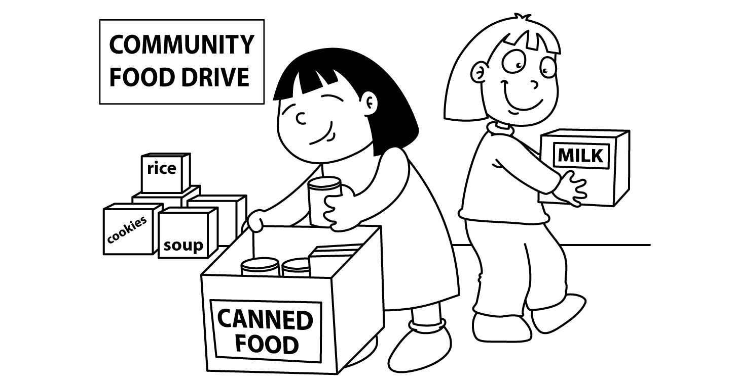

MONTH of NOVEMBER
Sunday | Monday | Tuesday | Wednesday | Thursday | Friday | Saturday
 |  | 1  Emersyn  Conferences | 2  NO SCHOOL | 3  Porter  Conferences | 4  NO SCHOOL | 5
6 | 7  Asher | 8  Bryson | 9  NO SCHOOL | 10  Eli | 11  Aria | 12
13 | 14  NO SCHOOL | 15  Landry | 16  Daniel  Preschool Make-up day | 17  Lucas | 18  Cohen | 19
20 | 21  Gunner | 22  Gavin | 23  NO SCHOOL | 24  NO SCHOOL | 25  NO SCHOOL | 26
27 | 28  Emersyn | 29  Asher’s birthday | 30  NO SCHOOL
We have 12 students for snack. Your child’s snack day is also their show and tell day.

